DMP Greater Bay Area Industrial Expo 27-30/11/2023

Interpreter/Receptionist Application Form

Company Name: Booth Number:
Contact Person: Tel:
Signature or Stamp: Email:
Please send this form to joanna.zhou@eshowyz.com
Language | Daily Rate  (RMB) | Number Required | Gender | Date
Chinese/English | 800
Chinese/Japanese、Korean | 1,300
Chinese/French | 1,400
Chinese/German | 1,400
Chinese/Russia | 1,400
Chinese/Italian | 1,500
Chinese/Spanish | 1,500
Receptionist/hostess/model | Starting from 700

Receiver’s Bank:
A/C Name: ESHOW Exhibition Services Co., Ltd
A/C No.: 3602 0150 0920 1164 277
BANK NAME: INDUSTRIAL AND COMMERCIAL BANK OF CHINA
GUANGZHOU YUEXIU BRANCH
BANK ADD.: 1F N 2F, REGAL COURT, NO.550-560, TIAN HE BEI LU, TIANHE DISTRICT,
GUANGZHOU, GUANGDONG, CHINA, P.R.
POST CODE: 510630
CNAPS No.: 102581000249
SWIFT CODE: ICBKCNBJGDG
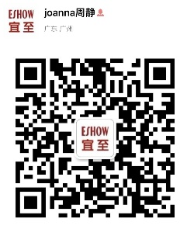
For more information, please contact:
Joanna Zhou
ESHOW Exhibition Services
Email: joanna.zhou@eshowyz.com
Mobile: +86-159-1581-1021
Website: www.eshowyz.com

